

Foundations of Programming
Assignment No. : 10

PROBLEM STATEMENT:
Write a program in C to simulate a simple calculator that performs basic arithmetic operations such as addition, subtraction, multiplication, and division. The calculator should also perform special operations like computing xʸ (power) and x! (factorial).

OBJECTIVE:
• To understand the use of switch-case statements in C.
• To perform basic arithmetic and special mathematical operations.
• To enhance problem-solving skills using menu-driven programs.

THEORY:
A calculator is a basic computing device used to perform arithmetic operations. In C programming, a simple calculator can be implemented using conditional or switch-case statements. Arithmetic operations like addition, subtraction, multiplication, and division are fundamental operations. Special operations such as power (xʸ) and factorial (x!) require loops for repeated calculations.

PLATFORM:
Linux

ALGORITHM:
- Start
- Display a menu with calculator operations
- Read the user’s choice
- If the choice is addition, subtraction, multiplication, division:
Read numbers from user; perform selected operations
If choice is power
Read base and exponent; Compute result using a loop
If choice is factorial
Read a number and compute factorial using loop
- Check if user chooses a divisor as zero then display “Error”
- Else display result of operation
- Stop

FLOWCHART:

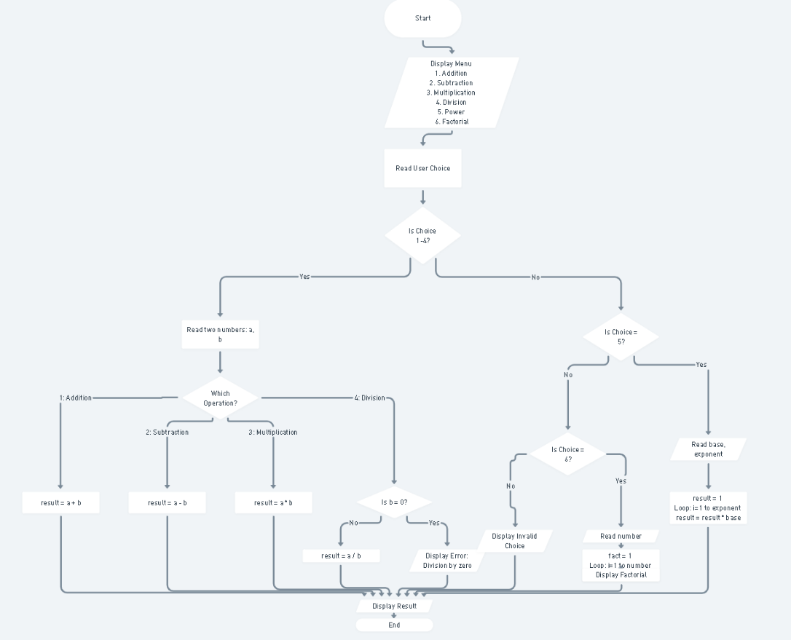

C PROGRAM:
#include <stdio.h>

int main() {
int choice;
int a, b;
int i;
int result = 1;
int num, fact = 1;

printf("MENU\n");
printf("1. Addition\n");
printf("2. Subtraction\n");
printf("3. Multiplication\n");
printf("4. Division\n");
printf("5. Power\n");
printf("6. Factorial\n");

printf("\nEnter your choice: ");
scanf("%d", &choice);

if (choice >= 1 && choice <= 4) {
printf("Enter two numbers: ");
scanf("%d %d", &a, &b);

if (choice == 1) {
result = a + b;
printf("Result = %d", result);
}
else if (choice == 2) {
result = a - b;
printf("Result = %d", result);
}
else if (choice == 3) {
result = a * b;
printf("Result = %d", result);
}
else if (choice == 4) {
if (b == 0) {
printf("Error: Division by zero not allowed");
} else {
result = a / b;
printf("Result = %d", result);
}
}
}
else if (choice == 5) {
int base, exp;
printf("Enter base and exponent: ");
scanf("%d %d", &base, &exp);

result = 1;
for (i = 1; i <= exp; i++) {
result = result * base;
}
printf("Result = %d", result);
}
else if (choice == 6) {
printf("Enter a number: ");
scanf("%d", &num);

fact = 1;
for (i = 1; i <= num; i++) {
fact = fact * i;
}
printf("Factorial = %d", fact);
}
else {
printf("Invalid choice");
}

return 0;
}

INPUT:
User selects an operation from the menu and enters required values.
Example Input:
Choice: 1
Numbers: 10 20

OUTPUT:
Example Output:
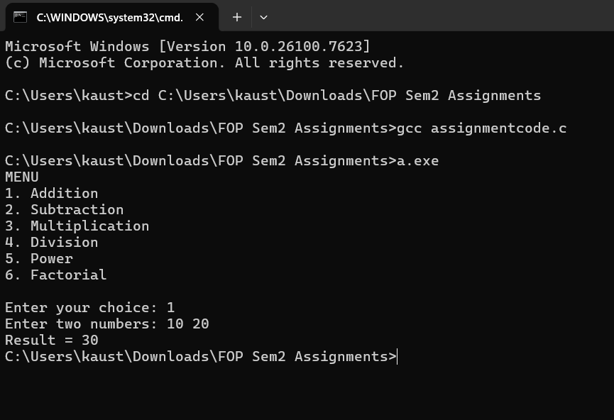
Result = 30.00

CONCLUSION:
Thus, a simple calculator program was successfully implemented using C programming. The program demonstrates the use of switch-case statements, loops, and arithmetic operations.

